1.How are inline and block elements different from each other?
A block-level element always starts on a new line and takes up the full width available (stretches out to the left and right as far as it can).
Example : <div>Hello</div>
An inline element does not start on a new line and only takes up as much width as necessary.
Example: <span>Hello</span>

2.Explain the difference between visibility:hidden and display:none
display: none removes the element from the normal flow of the page, allowing other elements to fill in.
Example : <a href="http://example.com" style="display: none;">unseen</a> link.<br />

visibility: hidden leaves the element in the normal flow of the page such that is still occupies space.

Example : <a href="http://example.com" style="visibility: hidden;">unseen</a> link.<br/>

3. Explain the clear and float properties.
The float property is used for positioning and formatting content e.g. let an image float left to the text in a container.
Example :
img {
float: right;
}
The clear property specifies what elements can float beside the cleared element and on which side.
Example :
div {
clear: left;
}
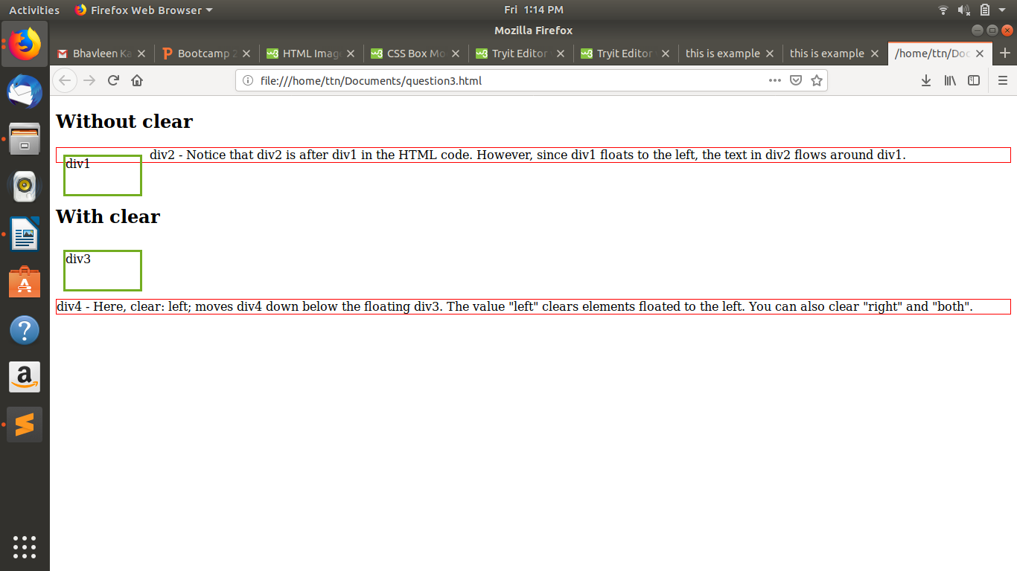

4. explain difference between absolute, relative,fixed and static.
The position property specifies the type of positioning method used for an element.
There are five different position values:
- static
- relative
- fixed
- absolute

An element with position: static; is not positioned in any special way, it is always positioned according to the normal flow of the page.
Example :
div.static {
position: static;
border: 3px solid #73AD21;
}
An element with position: relative; is positioned relative to its normal position.Setting the top, right, bottom, and left properties of a relatively-positioned element will cause it to be adjusted away from its normal position. Other content will not be adjusted to fit into any gap left by the element.
Example :
div.relative {
position: relative;
left: 30px;
border: 3px solid #73AD21;
}
An element with position: fixed; is positioned relative to the viewport, which means it always stays in the same place even if the page is scrolled. The top, right, bottom, and left properties are used to position the element.
A fixed element does not leave a gap in the page where it would normally have been located.
Example :
div.fixed {
position: fixed;
bottom: 0;
right: 0;
width: 300px;
border: 3px solid #73AD21;
}

An element with position: absolute; is positioned relative to the nearest positioned ancestor (instead of positioned relative to the viewport, like fixed).However; if an absolute positioned element has no positioned ancestors, it uses the document body, and moves along with page scrolling.
Example :
div.absolute {
position: absolute;
top: 80px;
right: 0;
width: 200px;
height: 100px;
border: 3px solid #73AD21;
}
5. Write the HTML code to create a table in which there are 4 columns( ID , Employee Name, Designation, Department) and at least 6 rows. Also do some styling to it.
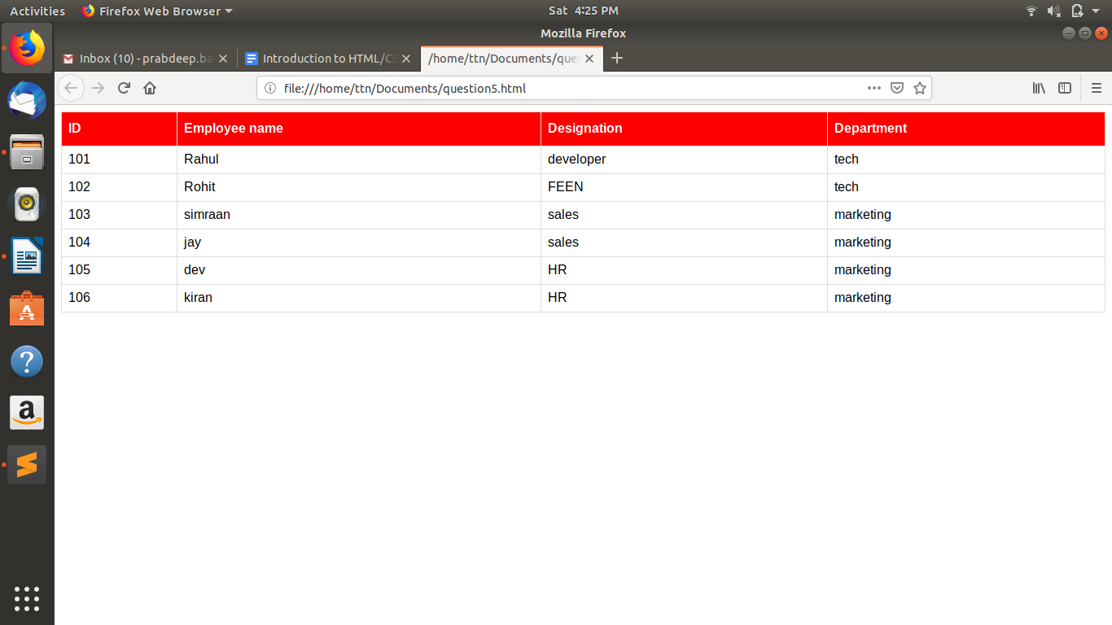

6. Why do we use meta tags?
The <meta> tag provides metadata about the HTML document. Metadata will not be
displayed on the page, but will be machine parsable.
<meta> tag is typically used to specify page description, keywords, author of the
document, last modified and other meta data
The metadata can be used by the browsers, like how to display content or reload
page.
Example :
<head>
<meta charset=“UTF-8”>
<meta name=“keywords” content=“HTML, CSS, XML, JavaScript”>
</head>

7. Explain box model.
The CSS box model is essentially a box that wraps around every HTML element.
It consists of :
- Content - The content of the box, where text and images appear
- Padding - Clears an area around the content. The padding is transparent
- Border - A border that goes around the padding and content

- Margin - Clears an area outside the border. The margin is transparent
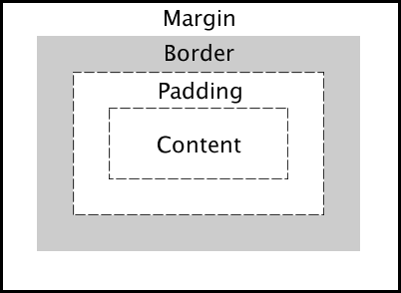

8. What are the different types of CSS Selectors?
• CSS selectors are used to select the content you want to style. They are part of
CSS rule set.
• There are several types of CSS Element Selector:
selectors in CSS :
CSS Element Selector:
<head>
<style>
p{
color : red;
}
</syle>
</head>
<body>
<p>Hello</p>
</body>

CSS id Selector
<head>
<style>
#key {
color : red;

}
</syle>
</head>
<body>
<p id=“key”>Hello</p>
</body>

CSS class selector
<head>
<style>
.key {
color : red;
}
</syle>
</head>
<body>
<p class=“key”>Hello</p>
</body>

CSS Universal selector
<head>
<style>
* {
color : red;
}
</syle>
</head>
<body>
<h1>Big Hello</h1>
<p>Hello</p>
</body>

CSS group selector
<head>
<style>
h1, p {
color : red;
}
</syle>
</head>
<body>
<h1>Big Hello</h1>
<p>Hello</p>
<h2>Bye</h2>
</body

9. Define Doctype.
• The <!DOCTYPE> declaration must be the very first thing in your HTML
document, before the <html> tag.
• The <!DOCTYPE> declaration is not an HTML tag; it is an instruction to the web
browser about what version of HTML the page is written in.
• In HTML 4.01, the <!DOCTYPE> declaration refers to a DTD, because HTML
4.01 was based on SGML. The DTD specifies the rules for the markup language,
so that the browsers render the content correctly.
• HTML5 is not based on SGML, and therefore does not require a reference to a
DTD.

10. Explain 5 HTML5 semantic tags.
1. <section> (Section)
A section is thematic grouping of content, typically with a heading.
2. <article> (Article)
This element specifies independent, self-contained content. An article should make
sense on its own, and it should be possible to read it independently from the rest of
the web site
3. <header> (Article)
It should be used as a container for introductory content at the top generally.
4. <footer> (Footer)
It should contain information about it’s containing element. A footer typically
contains the author of the document, copyright information, links to terms of use, etc.
5. <nav> (Navigation)
This tag defines a set of navigation links.

11. Create HTML for web-page.jpg (check resources, highest weightage for answers)

12. Create HTML for form.png (check resources, highest weightage for answers)

